**­**

**Total Marks: 05**

**Marks Obtained:**

**Software Engineering**

**Task # 01**

**Last date of Submission: June 11, 2022**

**Submitted To: Team Lead**

**Student Name: Muslih Uddin**

**Instructions:**

* *Copied or shown assignments will be marked zero.*
* *Late submissions will result in marks deduction.*
* *Hand written assignments are not acceptable.*

**Init Command:**

Initializes a new Git repository in your current directory, creating a .git folder to track version history.

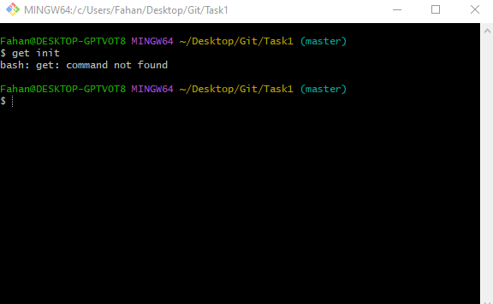

**Commit Command:**

Records the staged changes in the repository's history with a descriptive message. Use git commit -m "your message" to add a message.

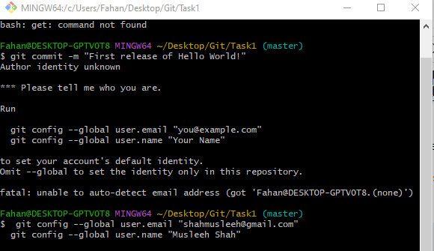

**Git add command:**

Stages changes (new, modified, or deleted files) to be included in the next commit. Use git add <file> to add specific files or git add . to add all changes.

